Mobile Application Design

CI141 Human Computer Interaction

**Introduction - (100-200 Words - suggested)** **2**

**Analysis, Investigation and Research - (minimum 800 words)** **2**

Competitor Analysis 2

Gojimo 2

Quizlet 3

The Application - (200 Words – suggested) 3

Scenarios and User Journeys - (minimum 600 words) 3

**Design** **3**

Interface Designs - (minimum 600 words) 3

Prototype 3

Evaluation - (minimum 500 words) 4

**Reflection - (300 words – suggested)** **4**

**Appendices** **4**

**References** **5**

# 

# **Introduction -** (100-200 Words - suggested)

A brief introduction to the project. Explain project context, and implication for HCI of relevant key issues, i.e. HCI design principles and Heuristics, ergonomics, cognitive and sociology.

The purpose of this assignment is to design and prototype a Mobile Phone application which will be used by other University of Brighton students. We have chosen to create a study application which will send the user questions throughout the day to test their knowledge and help them revise.

# **Analysis, Investigation and Research -** (minimum 800 words)

[An account of the investigation and analysis you carried out into literature, mobile and HCI principles, similar application and users and their needs, with your findings.

This will include brief descriptions of your personas and how you derived them. If you want us to see your original persona sketches and photos, you could include scanned versions or photos in an appendix. *Using extra user research methods such as demographic analysis or interviews will attract higher marks*.

Here you should also describe your competitor analysis, i.e. methodical research into similar, possibly non-digital, services. *Higher marks for an imaginative approach to this*.

Your investigation should also include gathering information about design conventions and constraints for your chosen platform and operating systems. For instance, if your system relies on GPS or streaming video, make sure the phones you specify can support this. *Reference to styleguides and HCI guidelines, including those specifically for mobile design, will attract higher marks*.]

## Competitor Analysis

### Gojimo

Gojimo is a free revision app with content from many different subjects, levels and exam boards. You can download quizzes to test your knowledge, track your progress and check off topics that you feel confident in. There is also help in other study areas such as exam tips and help with essay structures.

Gojimo’s target audience is GCSE and A level students, claiming that 1 in 3 students in this group use their app for revision. Whilst their target audience may be seemingly small, they have formed relationships with multiple large investors in the education industry.

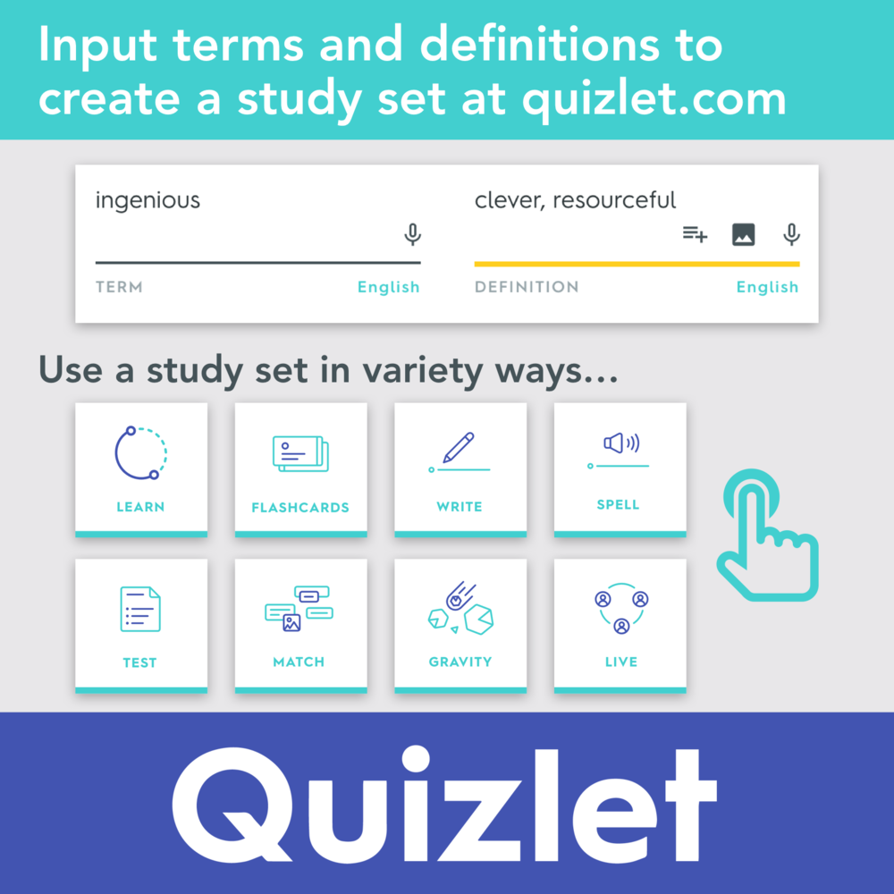

### Quizlet

This website makes it easy to quickly create revision flashcards or use those made by others. There are also games such as matching words with definitions, and interactive diagrams which make learning more enjoyable and interesting.

## **The Application -** (200 Words – suggested)

[This is where you describe which application you decided to develop and why. Describe its basic features, its name and how you envisage it being used. The markers will be looking for both *logic and imagination*.]

We decided to develop a study application to help students with revision for exams, and assist them in essay writing. This will quiz them with random questions throughout the day on topics they have chosen, and could feature a leveling system, so they answer questions to level up. To give extra incentive, there could be prizes for each level up, such as a voucher for a hot drink in the SU cafe, or vouchers for shops in town.

## **Scenarios and User Journeys -** (minimum 600 words)

[Describe three substantial scenarios and describe how they would be carried out with your system. The scenarios should test out a good range of the functionality/information resources of the system. You will need to refer here to your full requirements list, which you should include as an appendix. *Generating requirements from scenarios will attract higher marks*.]

# **Design**

## **Interface Designs -** (minimum 600 words)

[Wireframes showing the interface design for the service, with your design rationale. This should cover at least the screens used by the three scenarios. You may like to present other screen types if they are substantially different. *Reference to other systems and to platform style guides will attract high marks*].

## **Prototype**

(this will be mostly visual include Paper-based Low-fidelity Prototype and High-Fidelity Prototype)

[A brief introduction to your prototype explaining the strengths and weaknesses of the medium you choose. This will need to ref

er to the prototype itself, which can be included as an appendix, if it’s paper based, via photos if it’s a physical artefact or on a CD, if it’s digital, e.g. in PowerPoint. For digital prototypes, please include two or three screen grabs in Section 5 itself. *Thoughtful reflection on prototyping will attract high marks*.]

## **Evaluation -** (minimum 500 words)

[A detailed description of an evaluation session you carried out with one or more potential users (not part of your own group). You will need to describe preparation, recruitment, process during the session, treatment of results and implications for the design. The emphasis here is on quality of evaluation not quantity of users or tasks. *A professional testing process and realistic approach to the implications of the results will attract high marks*].

# **Reflection -** (300 words – suggested)

[A brief conclusion, reflecting on the process of user centred design, thinking about what aspects you found most/least useful. You may also include pointers to any further issues that would need to be addressed in turning this prototype into a real service, e.g. legal, business and other issues. This is the place to discuss how you allocated roles within your team and how that worked.].

# **Appendices**

You use appendices when you want to include material that doesn’t fit into the main document. Your personas, requirements, prototype and raw usability evaluation results are some possible candidates here.

## Appendix 1: Personas and Scenarios

## Appendix 2: Requirements list

|  |  |  |  |
| --- | --- | --- | --- |
| **Requirement Number** | **What needs to be achieved?** | **How will we achieve this?** | **Completed?** |
| 1 | Our application needs to be easy to use for everyone as not all students are great with computers. | We will ensure that the user interface is intuitive, and make sure that we have taken into account people with disabilities. | N |
| 2 | Needs to be accessible on all devices | Ensure that we create designs for phones and tablets as well as desktops | N |
| 3 | The application design needs to take into consideration those with sight impairments | We will ensure that an appropriate colour scheme is used to ensure text is easily readable | N |
| 4 |  |  |  |

## Appendix 3: Prototype (low-fidelity paper-based)

## Appendix 4: Prototype (high-fidelity paper-based)

## Appendix 5: Group Performa

And more as appropriate etc

# 

# **References.**

<http://www.gojimo.com/>

<https://quizlet.com/>

Group Profile

Piers Rust - 17811586 |

Jack Whitchurch - 1680193 |

Doryan Sadi - 17850125 |

John D Vos - 17806554 |

James Shaw - 17848280 |